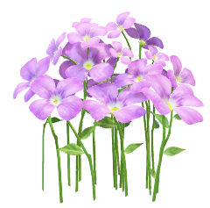
THIS WEEK’S WORD

Guess what this week’s word is folks. Suggested by our Jan!

Yes, you’ve got it. S P R I N G

The word can mean so many things, but for those of us who have been out walking or even doing our gardens there is now more of an element of this subject to enjoy. I have seen my first Orange Tip Butterfly this morning and the bluebells are coming into flower. You can no doubt think of a myriad things to write inspired by the word Spring. When the sun shines there is a spring in our step!

Deadline Monday 20th April. Send your finished little piece to Sunita for the website sunita.auger@googlemail.com

Happy designing!
Jane

